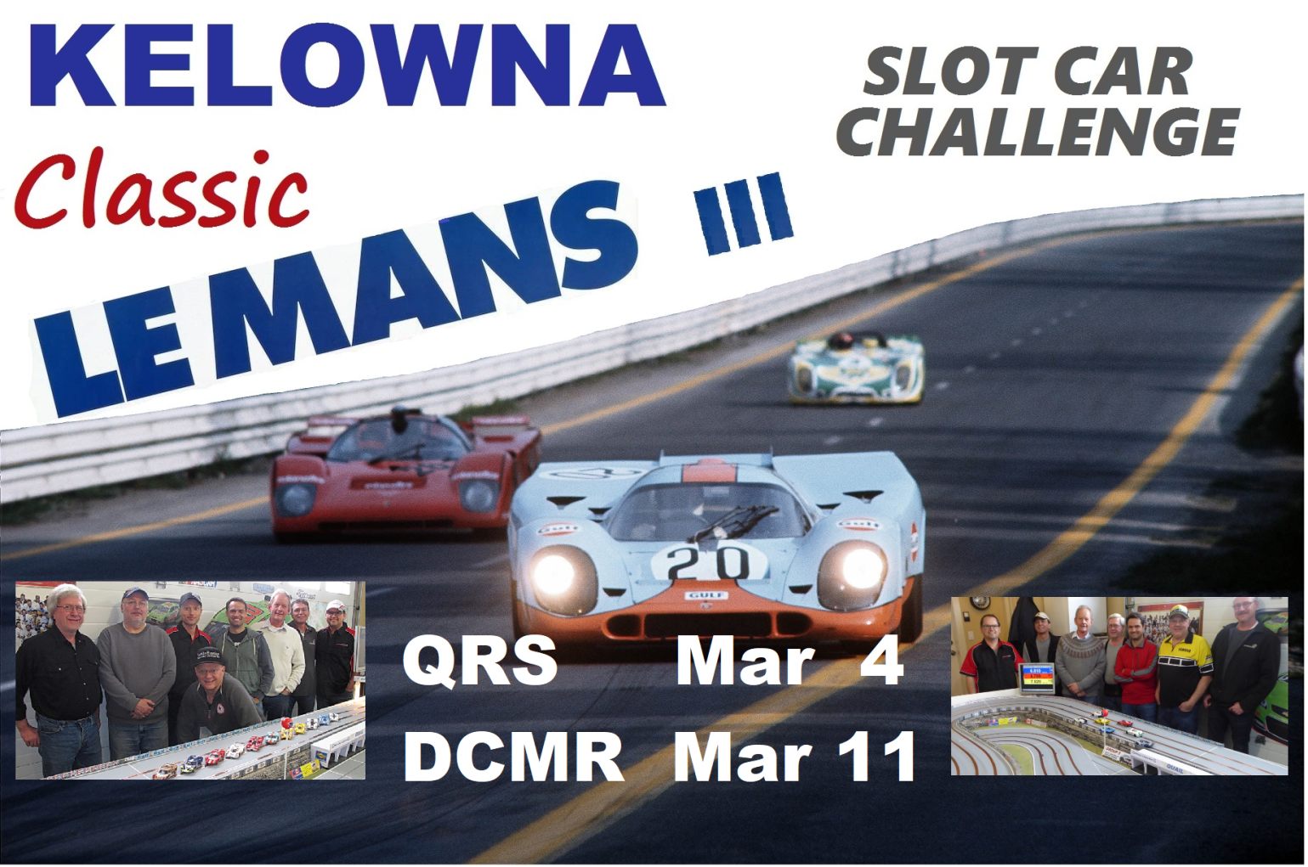

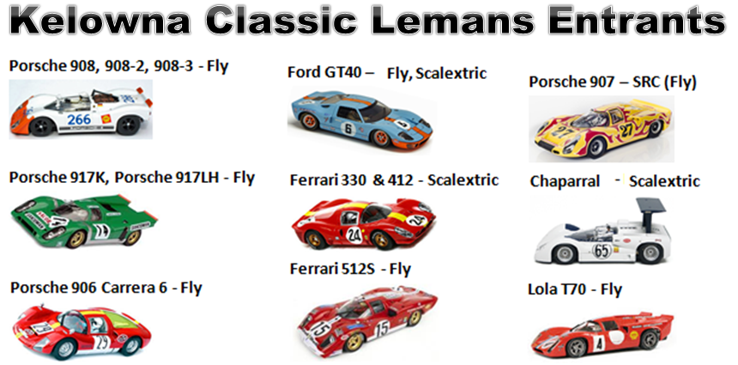

Eligible LeMans cars are a select group of 1/32 scale models of cars that raced at Le Mans during the years 1967-72. The car’s livery requires being time period correct for the 1967-72 LeMans racing (example: no GoDaddy or other such tasteless fantasy liveries). Custom fantasy liveries are allowed for our artistic racers but must be time period correct. Entries will be inspected March 4th at the QRS race held that day. If there are any car violations, there will be penalties applied. If there are any questions, it’s important to bring your car to a previous club race or just simply ask questions by email with photos attached.

Timeline:
Feb 12 – First day for entries. Entry to be approved. We can answer ANY questions you may have.
Feb 23 – Reminder. Reminder for entries and update. Send email / photos if any questions
Feb 27 – Final day for entries. Send us your final photos for a quick verification.
Feb 28 to Mar 3 – Allocation of Groupings / Entrants etc.
Mar 4 – Inspection / Race at QRS
Mar 11 – Inspection / Race at DCMR

Entrant Specifications - The exterior body/livery & hubs will maintain the original vintage look from the outside. Small exhausts / mirrors can be missing but large engine features and large exhaust features from the original body must be present.

Tires: Stock Rubber / Paul Gage/ Yellow Dog only. No low profile tires. Min tire height 19mm front - 19.5mm rear
Axles, Hubs, Bushing, Crown & Pinion Gear, Motor: Open
Hubs: Open - any manufacturer. Original plastic hub, insert hub with time period correct insert or five spoke metal hubs (must be painted) are allowed. Hubs not allowed protruding past the fender. Curved outer wall of tire allowed being outside fender (0.5 mm max general guideline for protruding). No “slammed” lowered stance.
Wheel Inserts: To maintain the look of this period no modern style multi spoke hubs/inserts and no mismatched hubs/inserts (including color). Look at the original cars to see what the “look” is.
Four options for wheels:
- Original Scalextric / Fly Classic hub turned down to be used as inserts for the insert hubs. If you do not have the original hubs, then you can use a different Scalextric / Fly Classic hub for the insert that matches the classic Le Mans look for that car.
- Similar classic inserts from a 3rd party vendor such as CG SlotCars which SCCC supplies now. Many different styles available.
- CB has 5 spoke metal hubs (not the racing hub version) which must be painted to maintain the vintage look. Example, 5 spoke CB hubs painted black match Porsche 917 hubs (easiest option).
- Stock plastic hub if you do not want to change the hubs at all.
Guide: Open - any manufacturer, Guide must maintain the same forward position
Interior: Full detailed interior (driver, dashboard, steering wheel, seat). Driver correctly positioned correct height and distance from steering wheel. No Lexan interior. Interior bottom can be trimmed and raised to allow for weight placement & chassis clearance. A simple glance through the window to verify the cockpit will be used as last year.
Number: Minimum three racing numbers. Self-created numbers must be minimum 10mm high.
Chassis: Open to any chassis - stock, kit, metal, brass, or plastic. Chassis and front spoiler must have 1.5mm clearance from roadway. No lead weight installed on outside of chassis.
Rear Spoiler: The original rear spoiler must be attached if it was originally manufactured with a rear spoiler. If the spoiler breaks off during a heat, the car owner will attempt to reattach or glue the spoiler back on before the next heat raced in.
KELOWNA CLASSIC LEMANS
SLOT CAR CHALLENGE