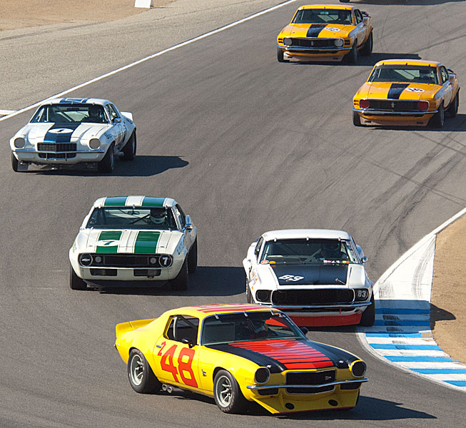
Classic
KSCC

April 3, 2016
March 20, 2016
TransAm
Challenge
American
Eligible KSCC Classic American TransAm Challenge Cars:
1/32 scale model slot cars of cars that were raced in the American TransAm series from 1966 to 1972. The liveries must be time period correct for the 1967-72 era (no modern period sponsors) or custom fantasy liveries are allowed. Numbers need to be clear and visible. Entries need to be confirmed ASAP. Any questions regarding the cars, please ask Lezlie or Henning.

Chevrolet Camaro:
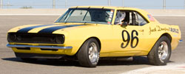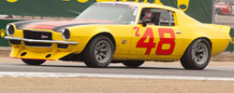

Ford Mustang:
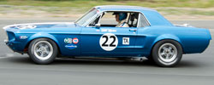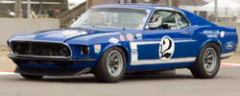
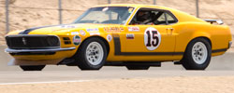

AMC Javelin: Mercury Cougar:
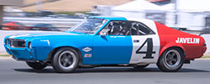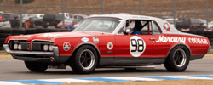

Dodge Challenger: Plymouth Barracuda:
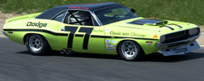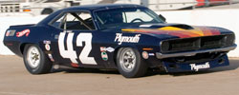

Dodge Dart:
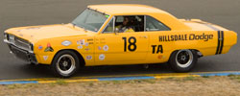
Timeline:
Please confirm intent to participate as soon as possible. This will help greatly with the setting up of various spreadsheets to record the race results.
Race 1: Tronson Model Raceway on 20th March 2016.
Race 2: Canalami Track on 3rd April 2016.

Body:
The exterior body/livery and will be period correct for the car entered and maintain the vintage look from the outside. Small exhausts / mirrors can be missing but large engine features and large exhaust features from the original body must be present.

Lights:
Cars must be equipped with light kits with working front and rear lights.

Tires:
Yellow Dog only. No Silicone.

Axles and Bushings:
Open – any manufacturer.

Crown and Pinion Gears:
Open – any manufacturer.

Motor:
Open – any manufacturer.

Hubs:
Open - any manufacturer. Metal hubs must not protrude past the fenders. Curved outer wall of tire may be outside fender (0.5 mm max general guideline for protruding).

Wheel Inserts:
No modern style multi spoke hubs or mismatched colored inserts. Scrutineering inspection will verify if the hubs / hub covers are appropriate for the car and time period.
Please use original Scalextric / Pioneer classic hubs turned down as inserts. If you do not have the original hubs then use period correct hub for insert.
Slot.it or similar inserts for vintage TransAm cars are acceptable if you do not have the original vintage hubs.
CB Design hubs 5 spoke and other vintage designed machined hubs are allowed and need to be painted to maintain the vintage look.

Guide:
Open - any manufacturer.

Interior:
Period interior must be represented inside the car. As a minimum a cardboard representation of the original interior is acceptable as long as the driver upper torso, arms, head and steering wheel is present and in acceptable position in the car body. This will allow for weight placement, chassis and motor clearance.

Racing Numbers:
A car should have a minimum of three racing numbers. The numbers should be placed on each side of the car and on the upper body. Numbers must be a minimum 10mm high.

Chassis:
Open to any chassis - stock, kit, metal, brass, or plastic. Chassis and front spoiler must have at least 1mm clearance from track. Use a tuning block hold up to a light to check for appropriate clearance between the chassis / spoiler and the tuning block

Spoiler:
The original rear spoiler must be attached to a car if it was originally manufactured with a rear spoiler. If the spoiler breaks off during a heat, the car owner will attempt to reattach or glue the spoiler back on before the next heat.

Weight:
No lead weights installed on outside of chassis.

General Overview.
Cars are divided into groups (Main A and Main B) of three and each car is driven for two minutes in each lane (red, blue, yellow) by each driver. Laps will be totaled for both race meetings at the Tronson Model Raceway and the Canalami track. Each car and driver will be judged by total number of laps completed.
Entries.
Please send details, by e-mail to Lezlie of proposed entries by 12th February 2016 with the following information:
Car make. (e.g. 1969 Mustang – Scalextric);
Motor;
Gearing;
Wheel size and make (e.g Slot.it metal);
Tire size.
Scrutiny and Inspection.
A check will be done for:
Track clearance;
Correct tires;
Tire clearance past body;
Working lights.
After scrutiny the cars will be placed in parc ferme and no further work will be done on the cars.
Tires may be cleaned once before the start of racing and braids may be adjusted. After the car has run a race, it will be placed in parc ferme again without any work being done to it (e.g. no tire cleaning etc.).
A prize for the best livery will be awarded. The car will be chosen by a vote of the entrants.
Race Format.
Cars will be divided into two groups, Main A and Main B.
The Main A group of cars will run Race 1 in the same lanes with the drivers rotating through the lanes until 6 Heats of 2 minutes each have been run.
For Race 2, the cars will be rotated into new lanes and the drivers rotated through the lanes until 6 Heats have been completed again.
For Race 3, the cars will be rotated into new lanes and the drivers rotated through the lanes until 6 Heats have been completed again.
The Main B group of cars will follow the same format as the previous Main A groups of cars.
Results will be recorded on a spreadsheet to show cumulative laps and times for each car and driver. These results will be carried over from the Tronson Model Speedway to the next race meeting at the Canalami track.
After the Tronson Model Speedway raced day, all cars will be secured in a box and considered to be in parc ferme until the next race meeting at the Canalami track.
Minor repairs may be carried out before the racing starts at the Canalami Track. This maintenance will not include opening the car unless in the case of a serious failure.
De-Slots.
Track call buttons will be in operation for both venues. Crash-and-burn format will not be followed. Each track call will affect driver results, so please respect drivers by trying to limit track calls to the minimum.
Bumping off.
Side swipe bumping off are requested to be kept to an absolute minimum out of respect to other drivers as this will influence their overall results.
Car Failure and Retirement.
Minor car problems will be ﬁxed (brushes) as needed but major failures will result in car retirement. A back-up car will be substituted only for driver lap scores and will no longer count for the car entry. The original car entry can be repaired for the following race.
Race 1: Tronson Model Raceway (20th March 2016)
Race 2: Canalami (3rd April 2016)
Results and Placings.
Overall car winner will be determined by the most laps completed. A tie will be resolved by the fastest lap time.
Overall driver winner will be determined by the most laps completed. A tie will be resolved by the fastest lap time.

